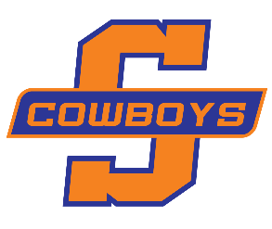
SOUTHWOOD BASKETBALL SPONSORSHIPS 2018-19
Tax ID No. 72: 6000224
501(c) (3) Organization
Choose one of the sponsorship options below:

Dear Business & Community Supporter,

The Southwood High School Boys’ Basketball program is beginning its 2018-19 fundraising campaign and would like to invite you to be a sponsor for the upcoming basketball season. Your Southwood Cowboys Basketball sponsorship would give your company exposure to the many students and their families who support the Cowboys’ teams as well as those fans from competing schools.

ORANGE LEVEL SPONSOR  $250 | BLUE LEVEL SPONSOR  $350
Full size color Banner (3ft x 5ft) displayed  during the entire 2017-18 Basketball Season | Extra Large color banner (4ft x 6ft ) displayed  during the entire 2017-18 Basketball Season
*Yearly Renewal Rate: $200 | *Yearly Renewal Rate: $300
Listed on:  Facebook: southwoodhoops  Instagram: southwoodhoopsla  Twitter: southwoodhoops | Listed on:  Facebook: southwoodhoops  Instagram: southwoodhoopsla  Twitter: southwoodhoops

For Sponsorship Banners please provide:
 Camera ready art
 Email artwork to southwoodhoopsla@yahoo.com or mail to address listed below by Oct. 29th.
 Check made payable to Southwood Boys Basketball

Business Name: __________________________________________________
Contact Person: __________________________________________________
Street Address: __________________________________________________
City / State / Zip: __________________________________________________
Business Phone Number: __________________________________________
PLEASE CHECK YOUR ORDER STATUS:
__ RENEWAL: ___ NEW ORDER:

Mailing Address: Southwood High School
ATTN: Eddie J Hamilton
9000 Walker Road
Shreveport, LA 71118
If you have any questions, email: southwoodhoopsla@yahoo.com

THANK YOU FOR SUPPORTING SOUTHWOOD COWBOYS BASKETBALL
AND BEING A PART OF OUR TEAM!

